# Task#01

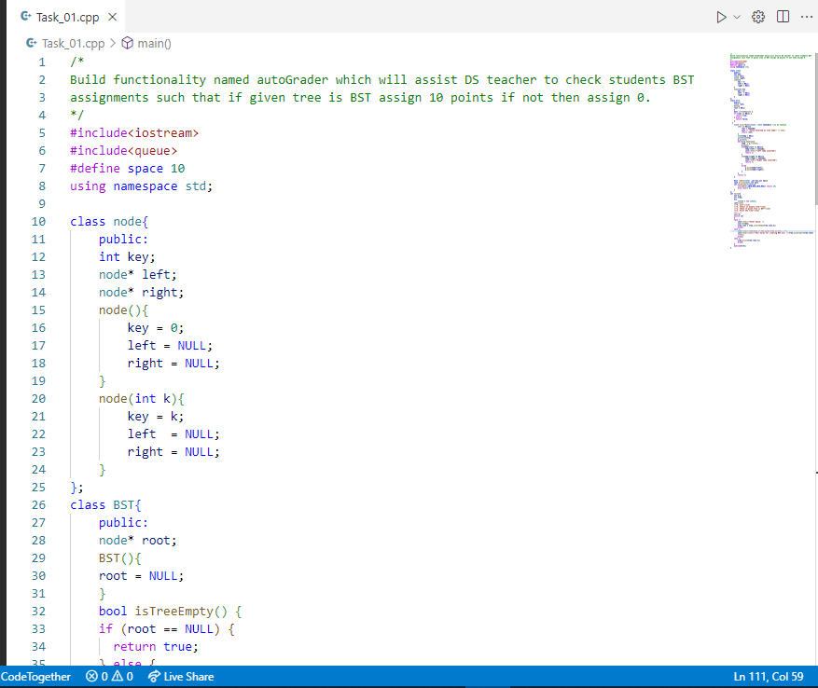

# Output:

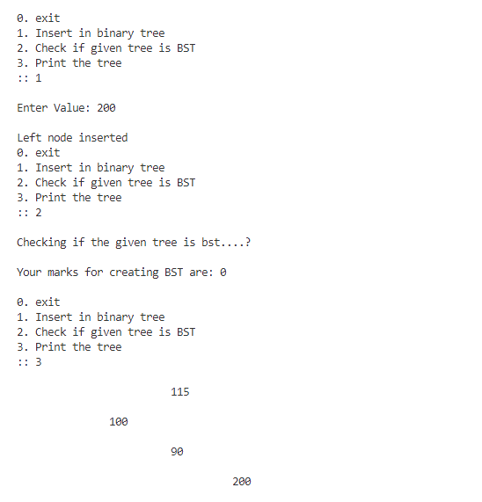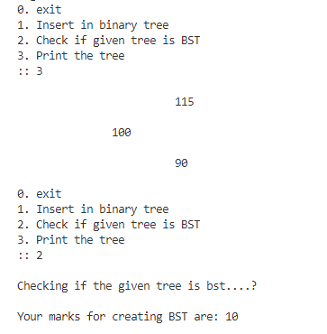

# Task#02

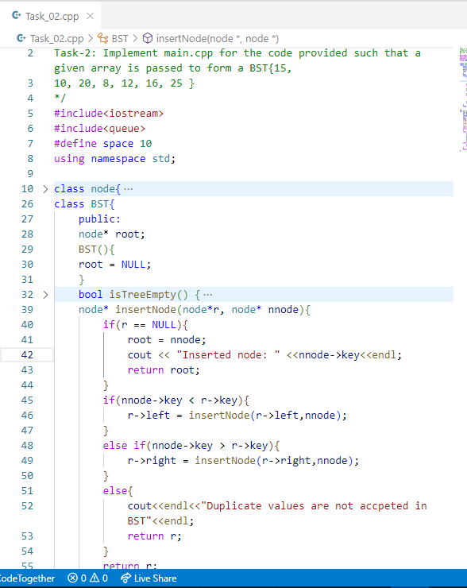

# Output:

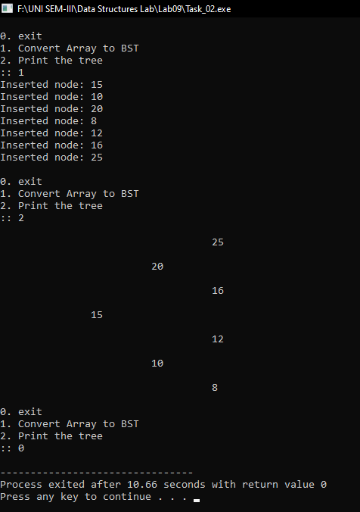

# Task#03 A

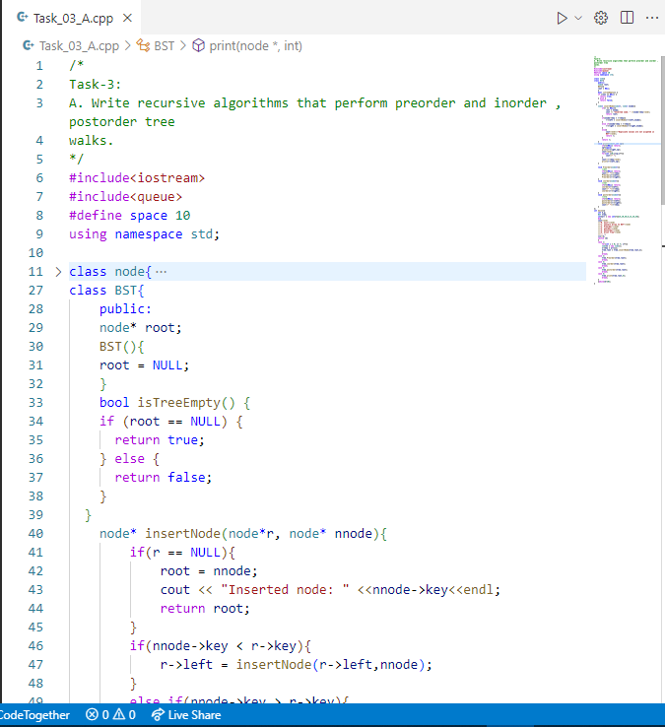

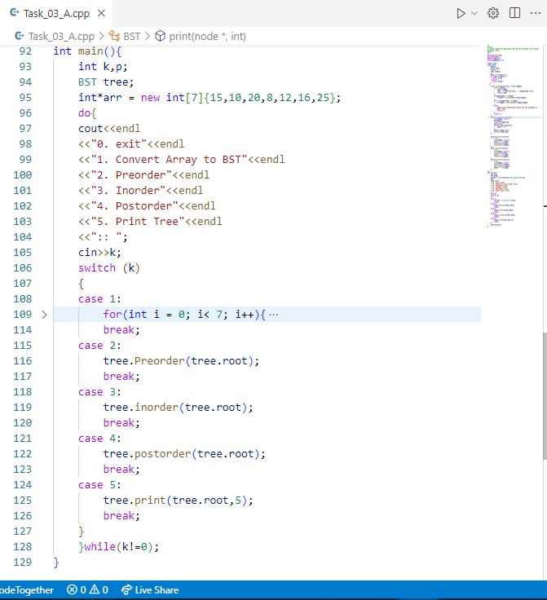

# Output:

# Task#03 B

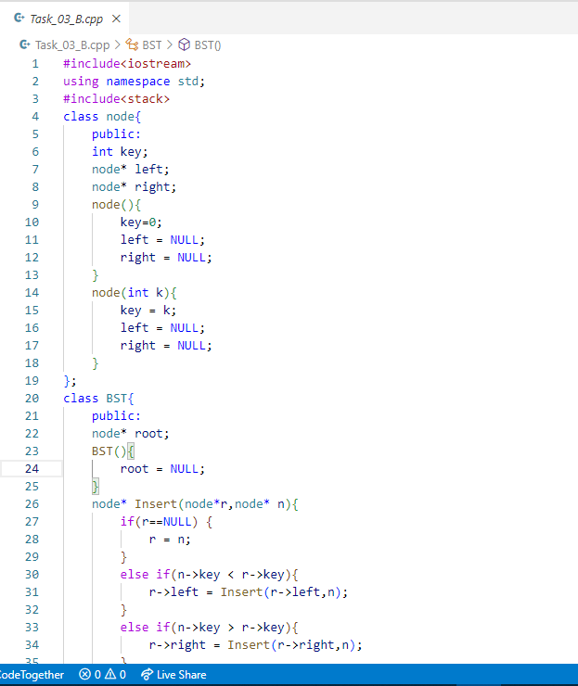

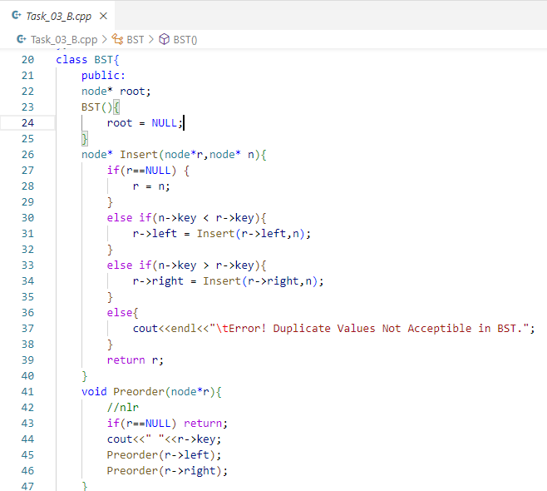

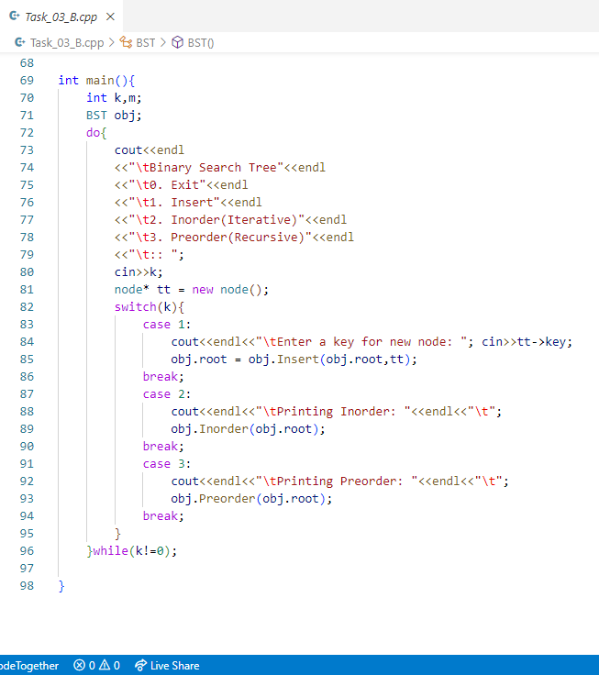

# Output:

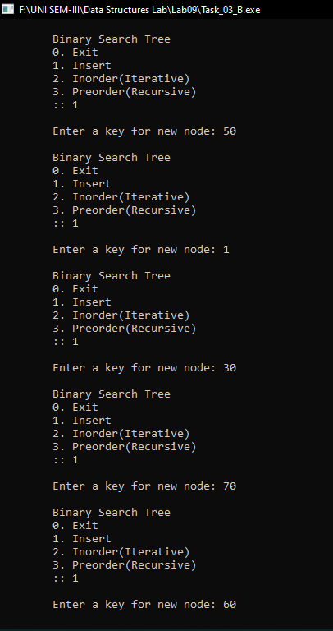

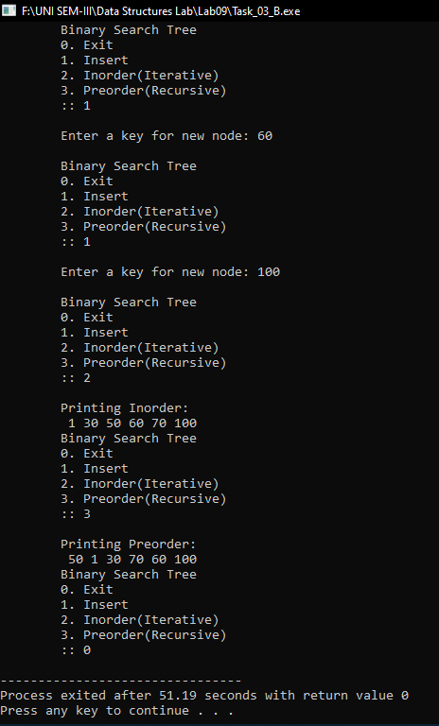

# Task#04

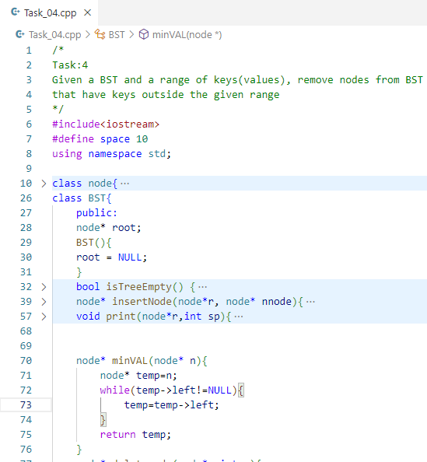

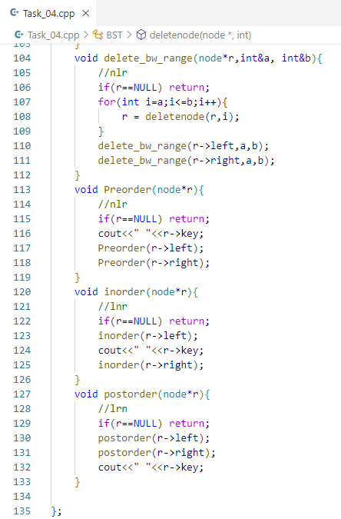

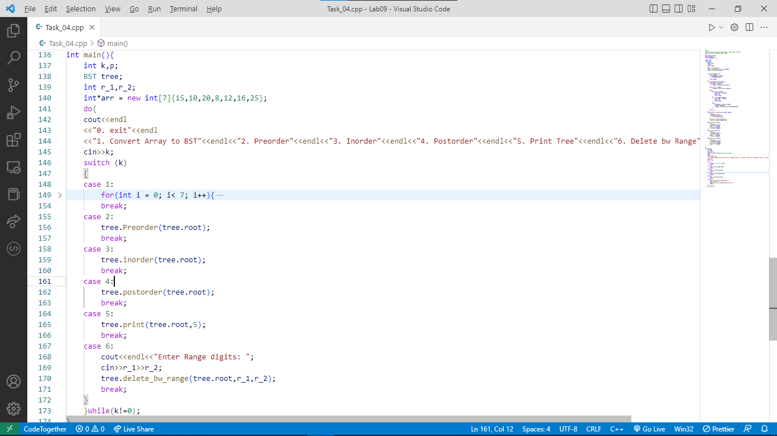

# Output:

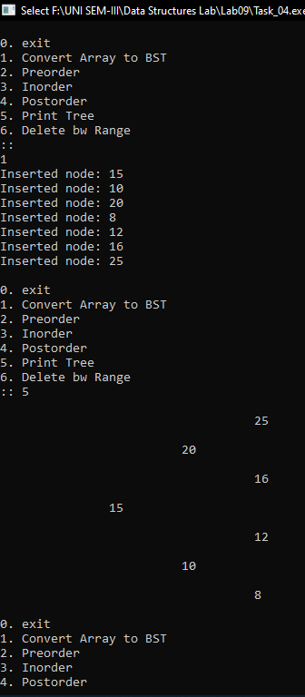

# Task#05

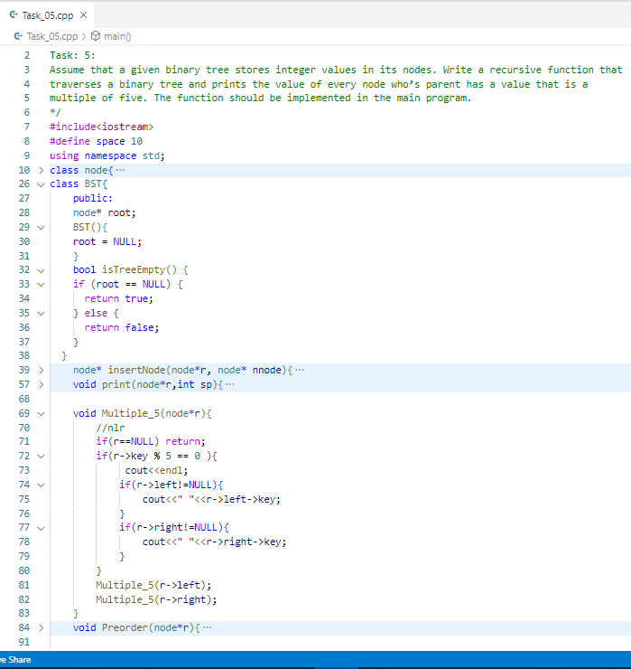

# Output:

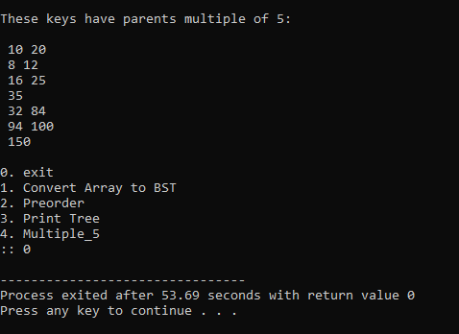

# Task#06

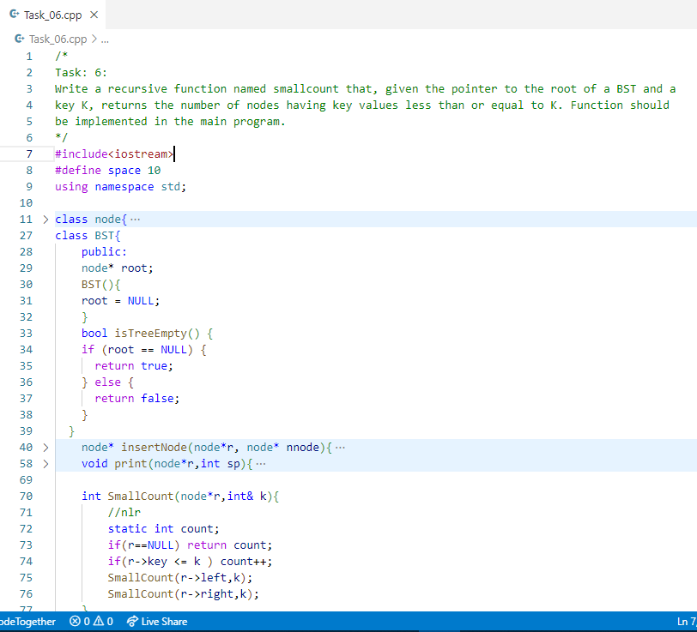

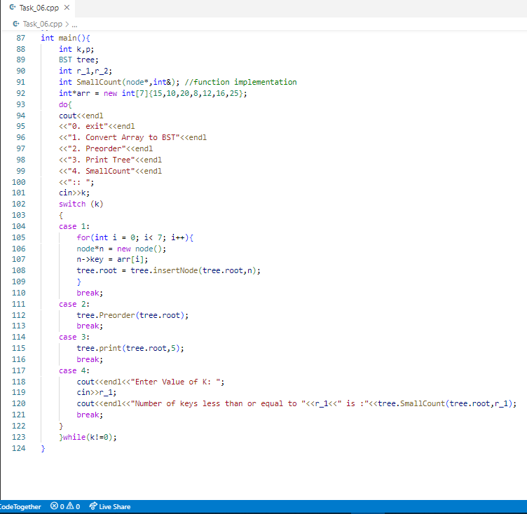

# Output:

